**Vanier College**

**Application Development**

**Final Project**

**Name: Joseph Jananji**

**Number: 2195417**

**Teacher: Alex Steinheuser Vilvert**

**Project Description:**

**BookBiz Distribution Inc.** is supplying computer science books to nearly all the colleges and universities in Quebec. You are required to design and implement a window-based application called **BookBiz Management System** using Visual Studio Enterprise 2015, C#.

**BookBiz’s** business requirements include the following:

1. Each book record should contain the fields: ISBN, Title, UnitPrice, YearPublished and QOH (quantity on hand). Each book must be categorized.
2. More than one author can write each book and each author can participate in writing more than one book. Each book can be published by only one publisher.
3. Each author record should contain the following pieces of information such as authorID (for identification in case authors have the same name), first name, last name and email).
4. **BookBiz** has received computer science books from different publishers (suppliers): Premier Press, Wrox, Murach, Prentice Hall and more.
5. **BookBiz’s** clients: Colleges and Universities in Quebec.

Each college/university should contain the information such as name, street, city, postal code, phone number, fax number and credit limit.

1. Order clerks can take clients ‘orders (by Phone, Fax, or Email) and order payments will be made by direct withdrawal from the college/university‘s bank account as specified in the contract between **BookBiz** and the client.
2. At present, **BookBiz** has two order clerks who are responsible for taking the clients’ orders.

**The login form to login the users:**

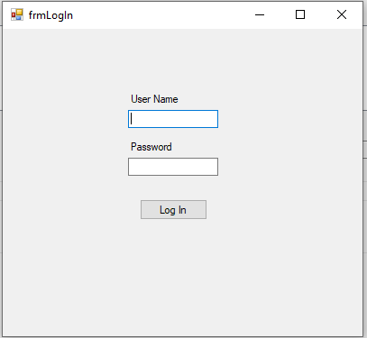

**The user information form to add, list and search user information:**

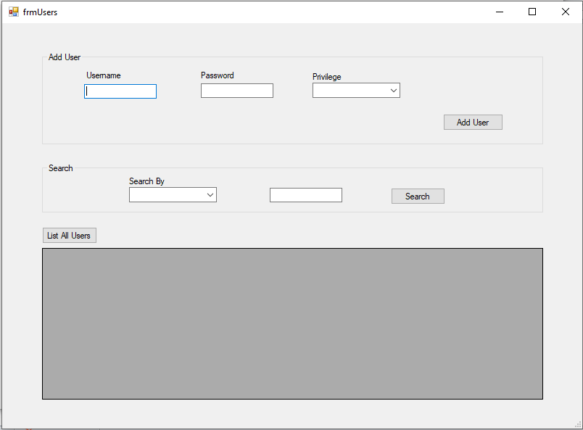

**The employee form to add, list and search employee information:**

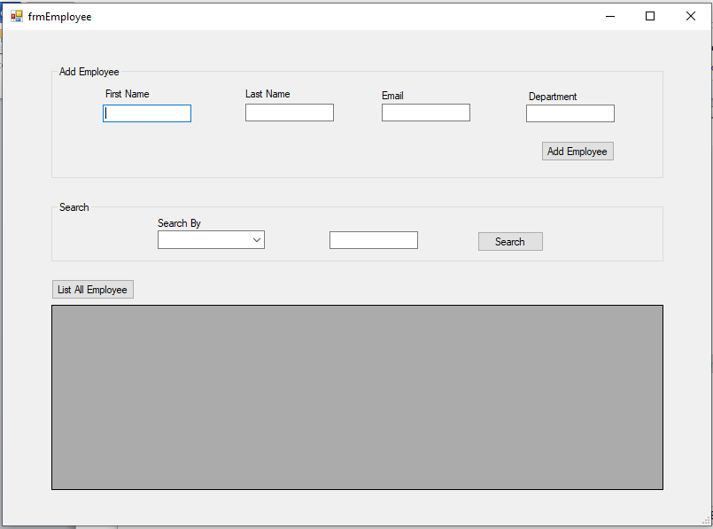

**The client information form to add, list and search client information:**

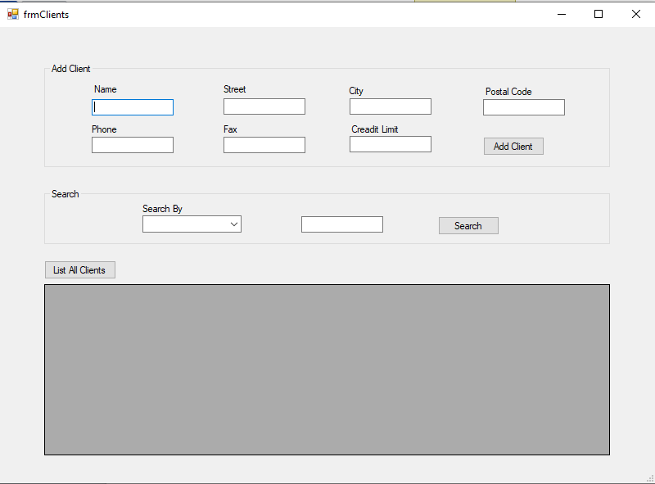

**The inventory form to add, list and search book information:**

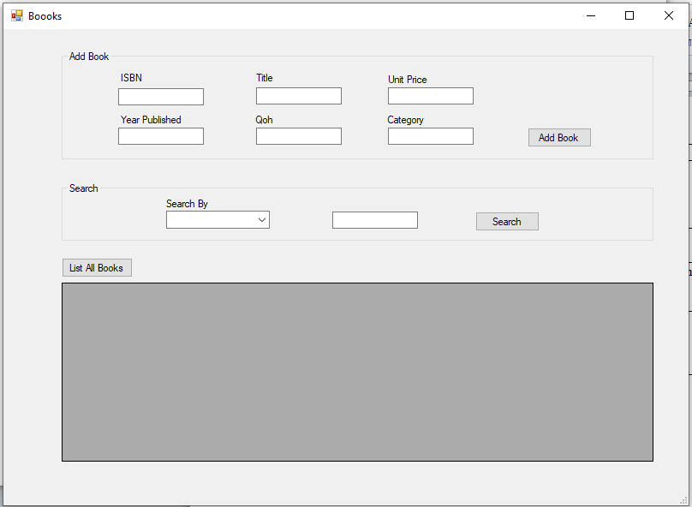

**The order forms to add, cancel, list and search order:**

